Array representation of Queue
We can easily represent queue by using linear arrays. There are two variables i.e. front and rear, that are implemented in the case of every queue. Front and rear variables point to the position from where insertions and deletions are performed in a queue. Initially, the value of front and queue is -1 which represents an empty queue. Array representation of a queue containing 5 elements along with the respective values of front and rear, is shown in the following figure.
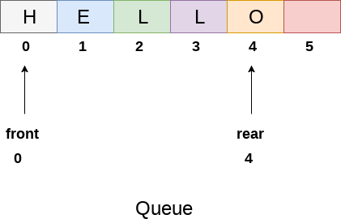
The above figure shows the queue of characters forming the English word "HELLO". Since, No deletion is performed in the queue till now, therefore the value of front remains -1 . However, the value of rear increases by one every time an insertion is performed in the queue. After inserting an element into the queue shown in the above figure, the queue will look something like following. The value of rear will become 5 while the value of front remains same.
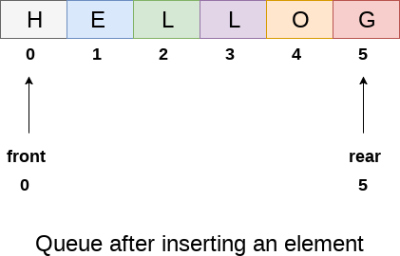
After deleting an element, the value of front will increase from -1 to 0. however, the queue will look something like following.
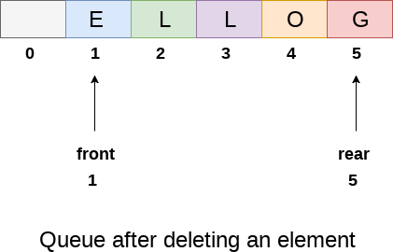

Algorithm to insert any element in a queue
Check if the queue is already full by comparing rear to max - 1. if so, then return an overflow error.
If the item is to be inserted as the first element in the list, in that case set the value of front and rear to 0 and insert the element at the rear end.
Otherwise keep increasing the value of rear and insert each element one by one having rear as the index.

Algorithm
- Step 1: IF REAR = MAX - 1
Write OVERFLOW
Go to step
[END OF IF]
- Step 2: IF FRONT = -1 and REAR = -1
SET FRONT = REAR = 0
ELSE
SET REAR = REAR + 1
[END OF IF]
- Step 3: Set QUEUE[REAR] = NUM
- Step 4: EXIT

C Function
void insert (int queue[], int max, int front, int rear, int item)
{
if (rear == max-1)
{
printf("Queue overflow");
}
else
{
if(front == -1 && rear == -1) //inserting the first element
{
front = 0; front ++
rear = 0;
}
else
{
rear = rear + 1;
}
queue[rear]=item; //enqueue
}
}

Algorithm to delete an element from the queue
If, the value of front is -1 or value of front is greater than rear , write an underflow message and exit.
Otherwise, keep increasing the value of front and return the item stored at the front end of the queue at each time.

Algorithm
- Step 1: IF FRONT = -1 or FRONT > REAR
Write UNDERFLOW
ELSE
SET VAL = QUEUE[FRONT]
SET FRONT = FRONT + 1
[END OF IF]
- Step 2: EXIT

C Function

int delete (int queue[], int max, int front, int rear)
{
int y;
if (front == -1 || front > rear)

{
printf("Queue underflow");
}
else
{
y = queue[front];
if(front == rear) // only one element in the queue
{
front = rear = -1; or front ++
else
front = front + 1;

}
return y;
}
}

Void show()
{
Int I;
For(i=front;i<=rear;i++)
Print(a[i])
0 1 2 3 4
1 2 3 4 5
F r

